**Chair Massage**

A **stiff neck**. Aching wrists. Shoulders that feel as if someone folded them up. Anyone who has ever sat behind a desk all day will recognize the symptoms of workplace fatigue.

According to David Palmer, co-developer of the first massage chair and founder of the TouchPro Institute in San Francisco, most office-related physical symptoms can be attributed to loss of circulation. **Tight muscles** caused by stress and sitting behind a desk all day, especially at a work station that is not ergonomically designed, can impede blood and lymph flow through the body. The result is **mental fogginess**, decreased energy and susceptibility to repetitive stress injuries, like carpal tunnel syndrome.

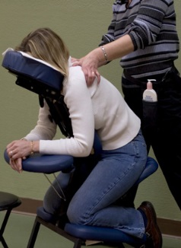Chair massage counters the circulatory problems inherent with office work—and provide a appreciated break for employees. Sitting in a massage chair opens up the back muscles, relieves strain on the neck and provides a gentle respite for eyes usually glued to a computer monitor. Even 15 minutes of massage to the neck, back, arms and hands can **increase circulation**, returning energy levels and helping keep the body injury free.

"When chair massage is used preventively, if you have problems it allows you to maintain a homeostatic balance that prevents the little problems from getting worse," Palmer said.

**"Enhancing circulation will enable the body’s self-healing mechanisms"**

- Kelle Walsh from Massage Magazine

Chair Massage  
Swedish Massage  
Shiatsu Massage  
Thai Massage

**Home** 